Stephen Dodd, M.Ed.

*Web-development, Science, and Technology enthusiast and philanthropist*

WORK BIO

RESUME CONTACT



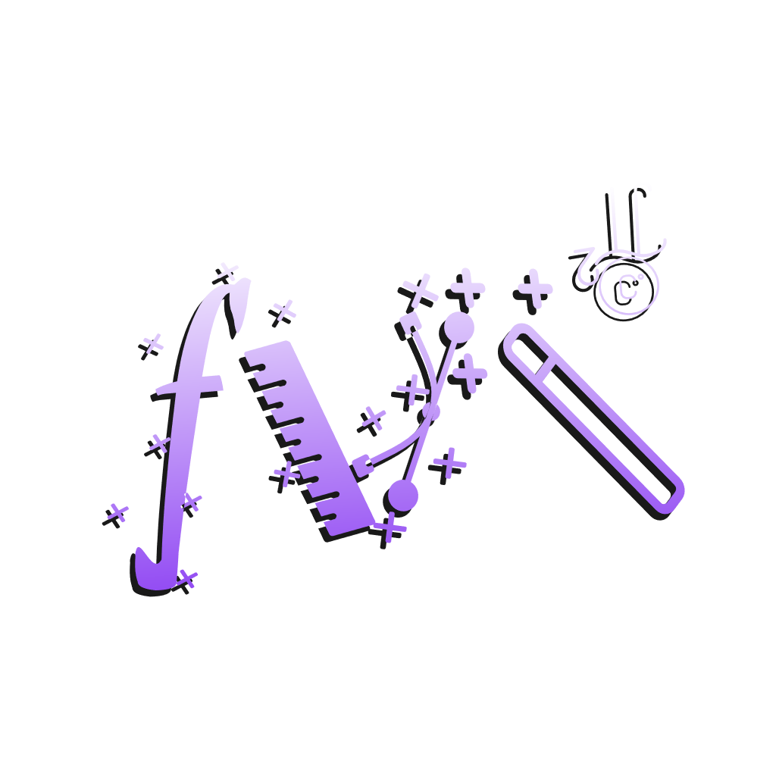

WORK - HOME

Mathemagical.org

*Addition Quiz adapted for children*

*Mathemagical.org/addition-quiz*

*Github.com/stephendodd1/Quiz-App*

*Uses jQuery/HTML/CSS/JS*

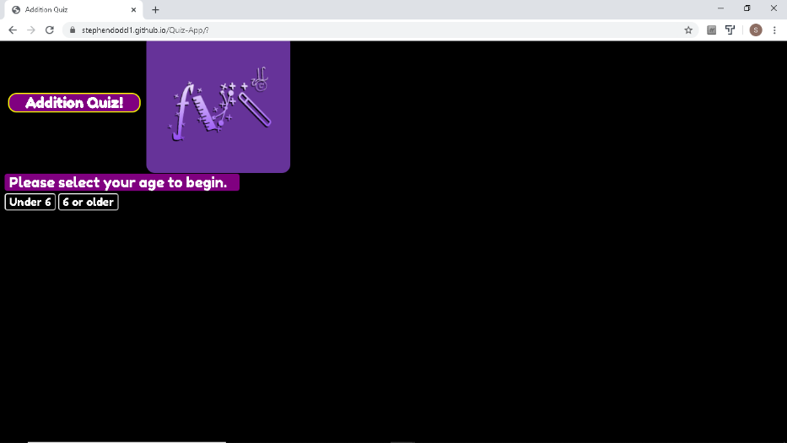

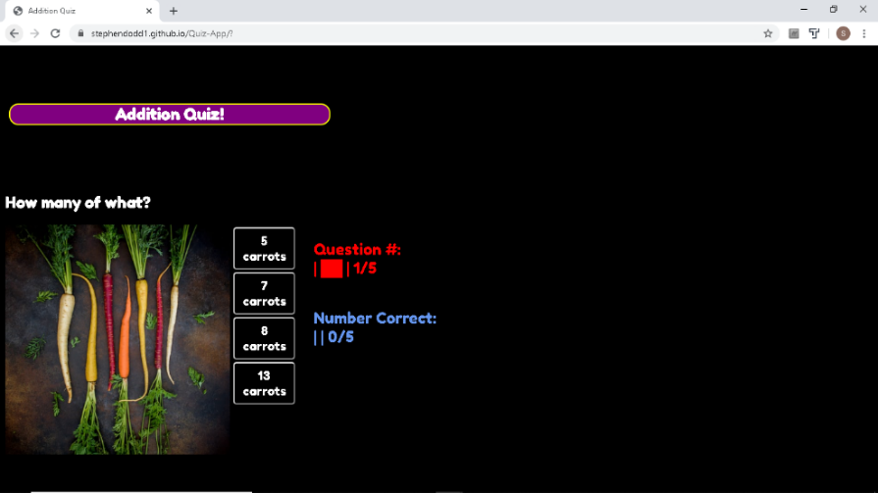

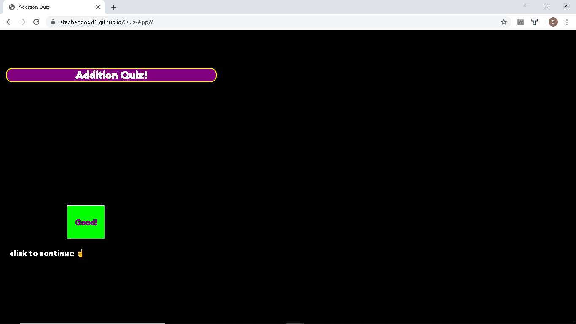

BIO - HOME

Stephen Dodd, M.Ed.



**Full-Stack Developer / High School Mathematics Teacher / Tutor at Mathemagical.org**

*Hi, I’m Stephen. I’m a Full-stack Developer, and STEAM enthusiast*

 I am a Thinkful Full-stack Flex Program graduate. I enjoy a good challenge. My passion is creating interactive, exciting webpages, that run seamlessly. I have been building apps in JavaScript, Java and Python for many years. I have hosted a few websites, the most recent being for my non-profit organization, Mathemagical.org. I want to be an artist to the gallery that is the web.

I have taught Secondary Mathematics in Title 1 schools for the past 5 years. In that time, I’ve had the pleasure of teaching everything from 7th grade mathematics to Second-year Advanced Placement Calculus. I enjoy my job, and I love the difference I make in the lives of children. However, I am ready to pursue my passion for content development.

I have been studying for most of my life. I am passionate about learning. I enjoy self-improvement immensely. In my free-time, I enjoy reading, watching, thinking about Science and Technology, and realistic Science-fiction, watching news, day-trading stocks and general tinkering. Some of my past projects have included hydroponic gardening, building an open-source 3-d printer, building PC’s, and of course, building apps and websites. I enjoy inspiring others to set goals and helping them reach those goals. I love to learn.

Bottom of page ^

CONTACT - HOME

***Stephen Dodd***

***Mathemagical.org***

***700 Smith St., Ste 61070,***

***Houston, TX 77002***

[Stephen@Mathemagical](mailto:StephenDodd@mathemagical.org)

[LinkedIn](https://www.linkedin.com/in/stephen-dodd-068b531a0)